St. Vincent Newsletter
September ELP & School Age
Welcome back to school! We hope everyone had a wonderful and fun filled summer! We are very happy to welcome our new and returning friends back into the room and are looking forward to an exciting year!
With a new year and new friends, we are hoping to once again fill our family tree with some special photos. Please bring a picture of your family so we can display it for our little ones to see. The tree has always been a hit for encouraging children to talk about their families with one another.
As much as it is September, the warm and sunny weather has decided to continue to stick around. Please be sure to send your child with sunscreen (or apply at home before they come) and a hat as we do play outside on occasion. Your child should also have a pair of indoor shoes and an extra change of clothes just in case things ever get “messy.”
Our ELP program is now using HiMama which is a program that provides electronic updates to your email address each day your child is here. You will catch a glimpse of what they did, what they ate, toileting and how their day was overall. Don’t forget to check your email! Please also stay tuned to our Facebook page or bulletin boards in the room for documentation and learning stores as they are posted.
Please do not hesitate to speak with us if you have any questions or concerns. We are happy to assist in any way we can!
October ELP & School Age
It’s hard to believe it’s October already! Our first month of school flew right on by! We’ve had an exciting month getting to know each other. We’ve made new friends and enjoyed some new experiences. We welcome Fall and are excited to encounter what it has in store for us.
We are very happy to see our new friends and families fitting into the program so well and would like to extend a warm welcome to our friends who have just recently joined us. We are always excited to see new faces!
Throughout the month of October, we will be incorporating bits and pieces of Fall and Hallowen into the program. We will also carve pumpkins and have a Halloween celebration (date TBA) towards the end of the month. Your child is invited to wear their Halloween costume on this day. Please note that you are not required to send treats for this day. Should you choose to, we kindly ask that you refrain from sending food items due to allergies within the program.

Just a few reminders:
We try to get outside with the children once a week with the ELP. With the colder weather coming please be sure your child has the appropriate clothing for outdoors each day they attend as our outdoor time is often spontaneous.
Be sure to check out the learning stories we have posted in the room as they showcase experiences within the program. The stories we post change periodically, so stay tuned! Most of these stories can also be seen on our Facebook page. Be sure to “Like” Ridge K.I.D.S. page.
We will be closed Monday October 10th for Thanksgiving and Friday October 28th for the PA Day.
Have a wonderful October!
Michelle and Melissa

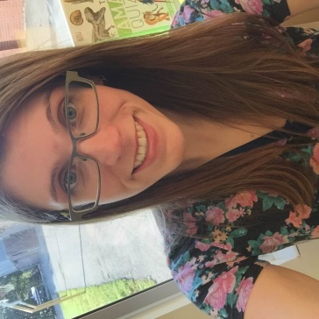
My name is Melissa. This is my second year working at the St. Vincent site. I love reading and I am currently reading Robert Galbraith's latest novel. I am also a big fan of Manchester United. I am excited for this new school year and I look forward to meeting everyone.

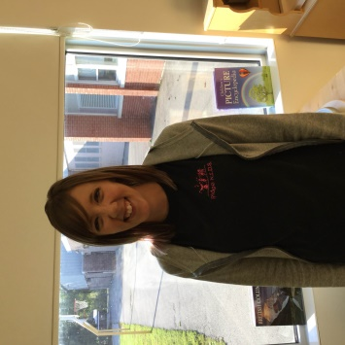
My name is Michelle and I have been a Registered Early Childhood Educator with Ridge K.I.D.S. for 5 years. I started out in Ridgetown, and this is my second year working in Chatham. I currently work with the before and after school program and ELP. I love my job and am excited to share a bit of my day with each and every child in my program. I have four fur babies and wouldn’t trade them for anything-a dog, two cats and a chinchilla. My fiancé and I enjoy fishing and tending to our home and garden, along with bonfires and barbeques. The winter months don’t stop us-we bundle up and ice fish and snowmobile as often as we can. I was born and raised in Chatham, although my father is from the States and moved back about 15 years ago. We travel to see him as often as we can. The rest of my family are primarily here, which makes it nice to have everyone so close. In my spare time, I play and teach piano. I also enjoy reading and spending time with friends and family.

